Engineering Design Challenge: Egg Drop Challenge

Name____________________________________________________

Overview: You are a member of NASA working on developing unique ways that both astronauts and space crafts are able to safely land on the ground without any damages. In order to do this, you are in charge of coming up with a structure that will be able to support a drop from a 10 ft drop.
Criteria:
In this challenge there are many different factors that must be followed. However, the end result must be the same- An intact egg. The rules are as follows
- The egg drop structure must fit in a 6”x6”x6” box
- The egg must be able to be placed in and taken out of the structure
- The structure must be able to support any trial runs.
- The structure can use only 5 of the materials from the list provided
- You can only use each material once. No repeats. For example, 5 plastic bags

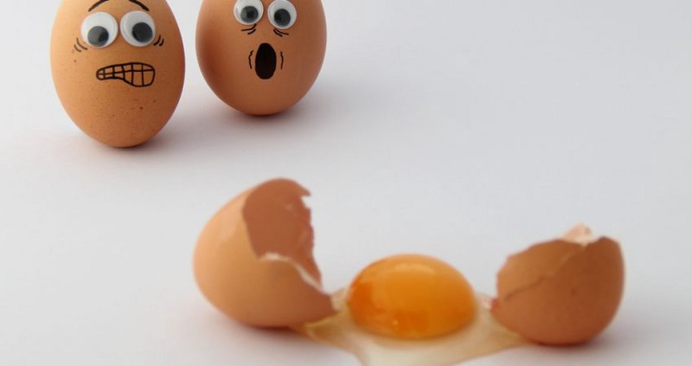
Brain Storming Phase
Material List
You may choose 5 of the materials for your design. ONLY CHOSE MATERIALS THAT YOU HAVE ACCESS TO. DO NOT feel the need to buy materials
- 1 plastic bag
- 3 rubber bands
- 20” of string
- 2 squares paper towels
- 2 water bottle tops
- 1 water bottle
- 3 pencils
- Handful of packing peanuts
- 4”x4” square of bubble wrap
- 2 plastic Easter eggs
- 3 sheets of computer paper
- 4 popsicle sticks
- 10 toothpicks
- 3 pipe cleaners
- 6 paper clips
- 20” of tape
- Hot glue
- Elmer’s glue
- 8” duct tape

Design Considerations:
Think about these questions while choosing and designing your egg crash car
- Do you want your car rigid and strong like a 1950s sports car? Or are there benefits if it collapses
- Should the egg be able to move freely, or should it be tightly strapped in?
- How can your structure be built to allow for easy removal and inspection of the egg?
- How are you going to minimize the impact?
- Are you going to model your idea after a preexisting model?
- How will you utilize all the materials provided?

In this step you will come up with three different well thought out ideas you will be able to list the pros and cons of the idea while also thinking about how each material could be used. USE LABELS IF DRAWING IS CONFUSING

- 4”x4” square of bubble wrap
- 2 Easter eggs
- 3 sheets of computer paper
- 4 popsicle sticks
- 10 toothpicks
- 3 pipe cleaners
- 6 paper clips
- 20” of tape
- Hot glue
- Elmer’s glue
- 8” duct tape

Materials
(Choose Only 5)
- 1 plastic bag
- 3 rubber bands
- 20” of string
- 2 squares paper towels
- 2 water bottle tops
- 1 water bottle
- 3 pencils
- Handful of packing peanuts
- 4”x4” square of bubble wrap
- 2 Easter eggs
- 3 sheets of computer paper
- 4 popsicle sticks
- 10 toothpicks
- 3 pipe cleaners
- 6 paper clips
- 20” of tape
- Hot glue
- Elmer’s glue
- 8” duct tape

Materials
(Choose Only 5)
- 1 plastic bag
- 3 rubber bands
- 20” of string
- 2 squares paper towels
- 2 water bottle tops
- 1 water bottle
- 3 pencils
- Handful of packing peanuts

- 4”x4” square of bubble wrap
- 2 Easter eggs
- 3 sheets of computer paper
- 4 popsicle sticks
- 10 toothpicks
- 3 pipe cleaners
- 6 paper clips
- 20” of tape
- Hot glue
- Elmer’s glue
- 8” duct tape

Materials
(Choose Only 5)
- 1 plastic bag
- 3 rubber bands
- 20” of string
- 2 squares paper towels
- 2 water bottle tops
- 1 water bottle
- 3 pencils
- Handful of packing peanuts

